Tab 1

1. Business Domain Understanding
This application manages iron ore dispatch using railway rakes.

What is a Rake?
A rake = a train consisting of multiple wagons carrying ore.
Example:
Rake: OK14
Wagon Type: NS/58
No of Wagons: 58
Ore Type: Lumps
Customer: JSPL Barbil
Destination: JSLK

Business Flow
- Railway provides empty wagons
- NMDC offers rake for loading
- Ore is loaded into wagons
- Loading status tracked
- Delays recorded
- Weight adjustments recorded
- Rake dispatched
This system tracks the entire lifecycle of a rake dispatch.

2. Current System Workflow (Derived from Screens)

Step 1 — Create Rake Offering
Screen: Rake Offering Details
User enters:
- Rake ID
- Rake Number
- Wagon Type
- No of Wagons
- Siding
- Route
- Ore Type
- Customer
- Destination
- FNote
- Placement Time
- Offer Time
Meaning:
Railway places rake → NMDC offers rake for loading.

Step 2 — Rake Listing
Screen: Update Loading Status
Shows:
Field | Meaning
Rake Number | Unique train ID
Wagon Supply | Wagon type & count
Deposit | Siding
Route | Route number
Customer | Buyer
Destination | Delivery point
FNote | dispatch note
Placement Time | wagon arrival
Offer Time | offered for loading
Actions:
- Edit
- Update Loading Status

Step 3 — Update Rake Loading
Screen: Update Rake Status
User enters:
- Operators
- FTP details
- Wagon Sick? (damaged wagon)
- Tonnage
- Stockpile
- Completion Time
- Track Clearance Time
- Delay reason
Meaning:
Loading operation tracking.

Step 4 — Delay Management
Screen: Update Reason for Delay
Captures:
- Delay Category
- Start Time
- End Time
- Reason
Example:
Category: Mechanical
Start: 04:50
End: 06:20
Reason: Wagon brake failure

Step 5 — Master Data
Menu:
Master
Wagon Type
Siding
Ore Type
Customer
Destination
Stockpile
These are reference data tables.

Step 6 — Load Adjustment
Screen: Adjustment Rakes
Tracks:
- Uneven load
- Overloaded wagon
- Weight removed
Example:
Rake: VK17
Reason: Load Adjustment
Overload wagons: 2
Weight removed: 4 tons

3. User Roles

1. System Admin
Responsibilities:
- Manage users
- Manage masters
- Reports
- System configuration

2. Dispatch Operator
Tasks:
- Create rake offering
- Update loading
- Enter FTP
- Record completion

3. Supervisor
Tasks:
- Approve loading
- Verify tonnage
- Validate delay reasons

4. Operations Manager
Tasks:
- Monitoring
- Reports
- Analytics
- Operational decisions

5. Railway Coordinator
Tasks:
- Wagon placement tracking
- Wagon health
- Railway communication

4. Core Modules for New System
If you rebuild from scratch, system should contain:

1. Authentication & Authorization
- Login
- Role based access
- Audit logs

2. Master Data Management
Manage reference entities:
- Wagon Types
- Sidings
- Ore Types
- Customers
- Destinations
- Routes
- Stockpiles

3. Rake Management
Create and manage rakes.
Functions:
- Create rake
- Modify rake
- Cancel rake
- Track rake lifecycle

4. Loading Management
Track loading operations.
Functions:
- Assign operators
- Record tonnage
- Wagon health
- Completion tracking

5. Delay Management
Track delay reasons.
Functions:
- Add delay
- Categorize delay
- Duration calculation

6. Load Adjustment Module
Handles:
- Uneven loading
- Overloading
- Weight removal

7. E-Demand Management
From menu:
E Demand
Upload Demand
View Pending Demand
This means:
Customers place ore demand.

8. Permit Management
Update EPermit
Update RTP
Likely:
Railway Transport Permit.

9. Reporting Module
Reports:
- Daily dispatch
- Customer dispatch
- Delay reports
- Wagon utilization

10. Dashboard
Operational overview.
Example metrics:
- Rakes today
- Loading in progress
- Delayed rakes
- Total tonnage

5. Functional Specification

5.1 Rake Offering

Inputs
- Rake Number
- Wagon Type
- Wagon Count
- Siding
- Route
- Ore Type
- Customer
- Destination
- FNote
- Placement Time
- Offer Time

System Validations
- Rake number unique
- Wagon count > 0
- Placement time <= Offer time

5.2 Loading Update

Inputs
- Operators
- FTP number
- Wagon sick
- Tonnage
- Stockpile
- Completion time
- Clearance time

System Logic
Loading duration =
Completion time - Placement time

5.3 Delay Tracking

Inputs
- Category
- Start time
- End time
- Description

Categories
Example:
Mechanical
Railway Delay
Power Failure
Labor Delay
Weather
Operational Issue

5.4 Load Adjustment
Captures:
- Overload wagons
- Weight removed
- Reason

6. Suggested Data Model
Main tables:
users
roles

rakes
rake_offering

loading_operations
delay_logs
adjustments

wagon_types
ore_types
customers
destinations
sidings
stockpiles

demands
permits

7. Scalable Architecture
For long term system.

Frontend
React / Next.js
Features:
- Dashboard
- Realtime updates
- Responsive UI

Backend
Java Spring Boot
Microservices:
auth-service
master-service
rake-service
loading-service
delay-service
report-service

Database
PostgreSQL

Event Streaming
Kafka
Example:
RAKE_CREATED
LOADING_STARTED
LOADING_COMPLETED
RAKE_DISPATCHED

Deployment
Docker + Kubernetes

Observability
- Prometheus
- Grafana
- ELK

8. Modern UI Improvements
Current UI is outdated.
New UI should include:

Dashboard
Example:
Total Rakes Today
Loading In Progress
Delayed Rakes
Total Tonnage
Charts:
- Dispatch trend
- Delay breakdown

Timeline View
For each rake:
Placement
Offer
Loading Start
Loading End
Dispatch

Drag-Drop Scheduling
Operators can assign rakes visually.

Mobile Friendly
Operators may use tablets.

9. Advanced Features (Future Scope)

1. Railway API Integration
Auto fetch:
- Wagon placement
- Wagon status

2. IoT Integration
Weight sensors.

3. AI Delay Prediction
Predict delays.

4. GPS Tracking
Track rake movement.

5. Analytics
Example:
Average loading time
Most delayed sidings
Customer dispatch trends

10. Example Rake Lifecycle
1 Railway provides rake
2 System creates rake offering
3 Loading starts
4 Operators update loading
5 Delay recorded if needed
6 Loading completed
7 Track cleared
8 Dispatch confirmed

11. Key Problem in Current System
Screens show:
- Poor UX
- No workflow visibility
- No dashboard
- No analytics
- No validation
- No scalability

12. Recommended New Product Vision
Build this as a Smart Dispatch Platform.
Capabilities:
- Real time monitoring
- Predictive operations
- Railway integration
- Analytics
- Mobile support

Tab 2
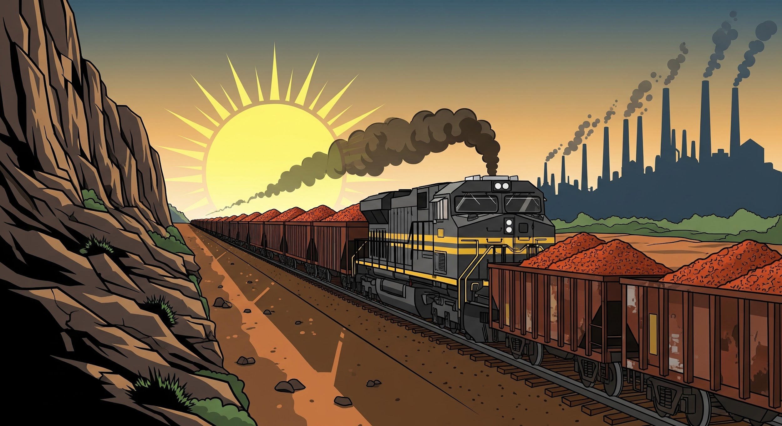

Iron Ore Dispatch System - Detailed Specification

1. Business Domain Understanding
This application is designed to manage the iron ore dispatch process using railway rakes.

A rake is defined as a train composed of multiple wagons used for carrying ore.

Field | Example
Rake ID | OK14
Wagon Type | NS/58
No of Wagons | 58
Ore Type | Lumps
Customer | JSPL Barbil
Destination | JSLK

The Business Flow involves:

- Railway provides empty wagons
- NMDC offers rake for loading
- Ore is loaded into wagons
- Loading status is tracked
- Delays are recorded
- Weight adjustments are recorded
- Rake is dispatched

This system tracks the entire lifecycle of a rake dispatch.

2. Current System Workflow (Screens & Steps)

Step 1: Create Rake Offering
Screen: Rake Offering Details

This action signifies that the Railway places the rake, and NMDC offers it for loading.

Input Field | Meaning
Rake ID | Unique Rake Identifier
Rake Number | Unique Train Number
Wagon Type | Type of wagon
No of Wagons | Count of wagons
Siding | Loading location (Deposit)
Route | Route number
Ore Type | Type of ore being loaded
Customer | Buyer name
Destination | Delivery point
FNote | Financial/Dispatch Note
Placement Time | Wagon arrival time
Offer Time | Time offered for loading

Step 2: Rake Listing & Action
Screen: Update Loading Status

Field | Meaning
Rake Number | Unique train ID
Wagon Supply | Wagon type & count
Deposit | Siding
Route | Route number
Customer | Buyer
Destination | Delivery point
FNote | Dispatch note
Placement Time | Wagon arrival
Offer Time | Offered for loading

Available actions are Edit and Update Loading Status.

Step 3: Update Rake Loading
Screen: Update Rake Status

This tracks the loading operation.

User inputs include:

- Operators
- FTP details (For example, Fast Track Planning)
- Wagon Sick? (damaged wagon flag)
- Tonnage
- Stockpile
- Completion Time
- Track Clearance Time
- Delay reason

Step 4: Delay Management
Screen: Update Reason for Delay

Field | Example Value
Delay Category | Mechanical
Start Time | 04:50
End Time | 06:20
Reason | Wagon brake failure

Step 5: Master Data Management
Reference data tables managed through the Master Menu:

- Wagon Type
- Siding
- Ore Type
- Customer
- Destination
- Stockpile

Step 6: Load Adjustment
Screen: Adjustment Rakes

This tracks corrections due to uneven or overloaded wagons.

Field | Example Value
Rake | VK17
Reason | Load Adjustment
Overload wagons | 2
Weight removed | 4 tons

3. User Roles and Responsibilities
The system supports role-based access for different operational needs.

Role | Key Responsibilities/Tasks
System Admin | Manage users, Manage masters, Generate reports, System configuration
Dispatch Operator | Create rake offering, Update loading status, Enter FTP details, Record completion
Supervisor | Approve loading, Verify tonnage, Validate delay reasons
Operations Manager | Monitoring, Reports, Analytics, Operational decisions
Railway Coordinator | Wagon placement tracking, Wagon health monitoring, Railway communication

4. Core Modules for New System Development (Detailed)
A scalable RDMS platform should be modular, meaning each capability is developed independently but integrated into the system.
This improves:
- maintainability
- scalability
- extensibility
- performance
Below are the recommended modules.

4.1 Authentication & Authorization Module

Purpose
Control who can access the system and what they can do.
This module ensures security and compliance.

Key Features

User Authentication
Users must login using:
- Username
- Password
- OTP (optional future enhancement)
Example:
Username: dispatch_operator1
Password: ********

Role-Based Access Control (RBAC)
Each user will have a role.
Example roles:
Role | Access
Admin | full system control
Dispatch Operator | create rakes, update loading
Supervisor | approve loading
Manager | view reports
Railway Coordinator | monitor wagon placement

Permissions
Permissions define actions allowed for roles.
Example:
Permission | Description
CREATE_RAKE | create new rake
UPDATE_LOADING | update loading details
ADD_DELAY | record delay
VIEW_REPORT | access reports
MANAGE_MASTER | edit master data

Audit Logging
Every action should be logged.
Example audit record:
User: operator1
Action: UPDATE_LOADING
Rake: OK14
Timestamp: 06-03-2026 16:45
This is important for:
- accountability
- compliance
- troubleshooting

4.2 Master Data Management Module

Purpose
Store static reference data used throughout the system.
This data rarely changes but is used frequently.

Entities Managed

Wagon Types
Example:
Wagon Type | Capacity
BOXN | 58 wagons
NS | 58 wagons
MIX | 59 wagons

Sidings
A siding is a railway track where loading happens.
Example:
Siding ID | Name
D10/11A | New Siding
D5 | Lump Siding

Ore Types
Example:
Ore Type
Lumps
Fines
ROM

Customers
Example:
Customer
JSPL Barbil
NMDC Steel
Welspun

Destinations
Example:
Destination
JSLK
JDB
ANGUL

Routes
Routes represent the railway route number.
Example:
Route ID
Route 1
Route 2

Stockpiles
Stockpiles represent the physical ore storage area.
Example:
Stockpile
Stockpile A
Stockpile B

Benefits
Centralized master data ensures:
- data consistency
- faster entry
- fewer errors

4.3 Rake Management Module

Purpose
This module manages the entire lifecycle of a rake.
A rake lifecycle includes:
Placement → Offer → Loading → Completion → Dispatch

Features

Create Rake
User enters:
Field | Description
Rake Number | unique identifier
Wagon Type | type of wagons
No of Wagons | count
Siding | loading location
Route | route id
Ore Type | type of ore
Customer | buyer
Destination | delivery location
FNote | dispatch note
Placement Time | wagon arrival time
Offer Time | offered for loading

Modify Rake
Users can update:
- customer
- destination
- wagon details
Before loading begins.

Cancel Rake
Rake can be cancelled due to:
- railway issue
- customer change
- operational problem

Track Lifecycle
Each rake should have status.
Example:
PLACED
OFFERED
LOADING
COMPLETED
DISPATCHED

4.4 Loading Management Module

Purpose
Track the actual loading operation.
This is the most critical module.

Features

Assign Operators
Operators responsible for loading.
Example:
Operator 1: Ram Kumar
Operator 2: Suresh Patel

Wagon Health
Sometimes wagons are damaged.
Example:
Is Wagon Sick?

Yes / No
If Yes, wagon must be removed.

Tonnage Recording
System records total loaded weight.
Example:
Total Tonnage = 3600 tons

Stockpile Selection
Ore source.
Example:
Stockpile: SP-A

Completion Tracking
Fields:
Field | Meaning
Completion Time | loading finished
Track Clearance | track released

4.5 Delay Management Module

Purpose
Track reasons for loading delays.
This is important for operational analysis.

Features

Add Delay
User records delay.
Fields:
Field | Description
Category | delay type
Start Time | when delay started
End Time | when delay ended
Reason | explanation

Delay Categories
Example categories:
Category
Mechanical
Railway Delay
Power Failure
Labor Delay
Weather
Operational Issue

Delay Duration Calculation
System calculates:
Delay Duration = End Time - Start Time
Example:
Start: 04:50
End: 06:20

Delay = 1 hour 30 minutes

4.6 Load Adjustment Module

Purpose
Handles weight imbalance issues.
Railway wagons have strict weight limits.

Scenarios

Uneven Loading
Example:
Left side heavy
Right side light
Adjustment required.

Overloaded Wagon
Example:
Allowed weight: 60 tons
Actual weight: 65 tons
Excess must be removed.

Data Captured
Field | Description
Overload Wagons | number of affected wagons
Weight Removed | weight removed
Reason | explanation

4.7 E-Demand Management Module

Purpose
Customers submit ore demand requests.
Example:
Customer: JSPL
Ore Type: Lumps
Quantity: 4000 tons
Date: 10-03-2026

Features

Upload Demand
Upload through:
- file
- manual entry

View Pending Demands
Shows unfulfilled demand.
Example:
Customer | Ore | Quantity
JSPL | Lumps | 4000
Welspun | Fines | 3000

4.8 Permit Management Module

Purpose
Railway movement requires permits.

EPermit
Electronic transport permit.
Fields:
Permit Number
Issue Date
Valid Till

RTP
Railway Transport Permit.
Tracks railway approval.

4.9 Reporting Module

Purpose
Provide operational insights.

Example Reports

Daily Dispatch Report
Date
Rakes Dispatched
Total Tonnage

Customer Dispatch
Customer
Rakes
Tonnage

Delay Analysis
Category
Total Delay Time

Wagon Utilization
Total wagons used
Average load per wagon

4.10 Dashboard Module

Purpose
Provide real-time operational visibility.

Dashboard Metrics
Example:
Metric | Value
Rakes Today | 12
Loading Now | 3
Delayed | 2
Total Tonnage | 14,500 tons

Charts
Suggested charts:
1️⃣ Dispatch trend
2️⃣ Delay distribution
3️⃣ Customer shipment share

5. Functional Specifications (Detailed)

5.1 Rake Offering Validation
System must validate:

Rake Number
Must be unique.
Example invalid case:
Existing: OK14
New Entry: OK14
Reject.

Wagon Count
Must be > 0.
Example:
Invalid: 0 wagons
Valid: 58 wagons

Time Validation
Placement must happen before offer.
Example:
Placement: 10:00
Offer: 09:30
Invalid.

5.2 Loading Duration Calculation
System automatically calculates loading time.
Formula:
Loading Duration =
Completion Time - Placement Time
Example:
Placement: 04:50
Completion: 06:20

Loading Time = 1 hr 30 min

5.3 Delay Tracking
Multiple delays can exist for a rake.
Example:
Delay 1:
Mechanical
04:50 - 05:30

Delay 2:
Power Failure
05:30 - 06:00
Total delay = 1 hr 10 min.

5.4 Load Adjustment
System records adjustment events.
Example:
Rake: VK17
Overloaded Wagons: 3
Weight Removed: 5 tons
Reason: Uneven loading

Recommended Additional Functionalities
If you are redesigning, I strongly recommend adding:

Live Dispatch Board
Like airport departure board.
Shows:
Rake
Customer
Status
Delay

Real-Time Notifications
Example:
Rake OK14 loading completed

Mobile Tablet Interface
Operators use tablets near loading site.

Predictive Delay Analytics
AI predicts:
Possible delay due to weather

GIS Map Integration
Show rake movement.

6. Suggested Data Model
The core system should be structured around these main tables:

Category | Tables
Security | users, roles
Core Rake Flow | rakes, rake_offering, loading_operations, delay_logs, adjustments
Master Data | wagon_types, ore_types, customers, destinations, sidings, stockpiles
External Integration | demands, permits

7. Scalable Architecture
To ensure a long-term, scalable solution, the following architecture is suggested:

Component | Technology / Strategy | Key Features
Frontend | React / Next.js | Dashboard, Realtime updates, Responsive UI
Backend | Java Spring Boot (Microservices) | auth-service, master-service, rake-service, loading-service, delay-service, report-service
Database | PostgreSQL | Robust and reliable relational data storage
Event Streaming | Kafka | Real-time notifications for RAKE_CREATED, LOADING_COMPLETED, etc.
Deployment | Docker + Kubernetes | Containerization and Orchestration for scalability
Observability | Prometheus, Grafana, ELK | Monitoring, Visualization, and Logging

8. Modern UI Improvements
To address the poor UX of the current system, the new UI must include:

- Dashboard: Real-time metrics such as Rakes Today, Loading In Progress, Delayed Rakes, Total Tonnage, and visual charts (Dispatch trend, Delay breakdown).
- Timeline View: A visual flow for each rake showing Placement, Offer, Loading Start, Loading End, and Dispatch events.
- Drag-Drop Scheduling: A visual interface for operators to assign rakes.
- Mobile Friendly: Full responsiveness for tablet use by field operators.

9. Advanced Features (Future Scope)
These features will enhance the platform's efficiency:

- Railway API Integration: Automatically fetch wagon placement and status.
- IoT Integration: Incorporate weight sensor data.
- AI Delay Prediction: Use machine learning to predict potential delays.
- GPS Tracking: Track the movement of rakes post-dispatch.
- Analytics: Provide insights into Average loading time, Most delayed sidings, and Customer dispatch trends.

10. Recommended New Product Vision
The new system should be branded and developed as a Smart Dispatch Platform with the following core capabilities:

- Real time monitoring
- Predictive operations
- Railway integration
- Advanced Analytics
- Mobile support

Tab 3
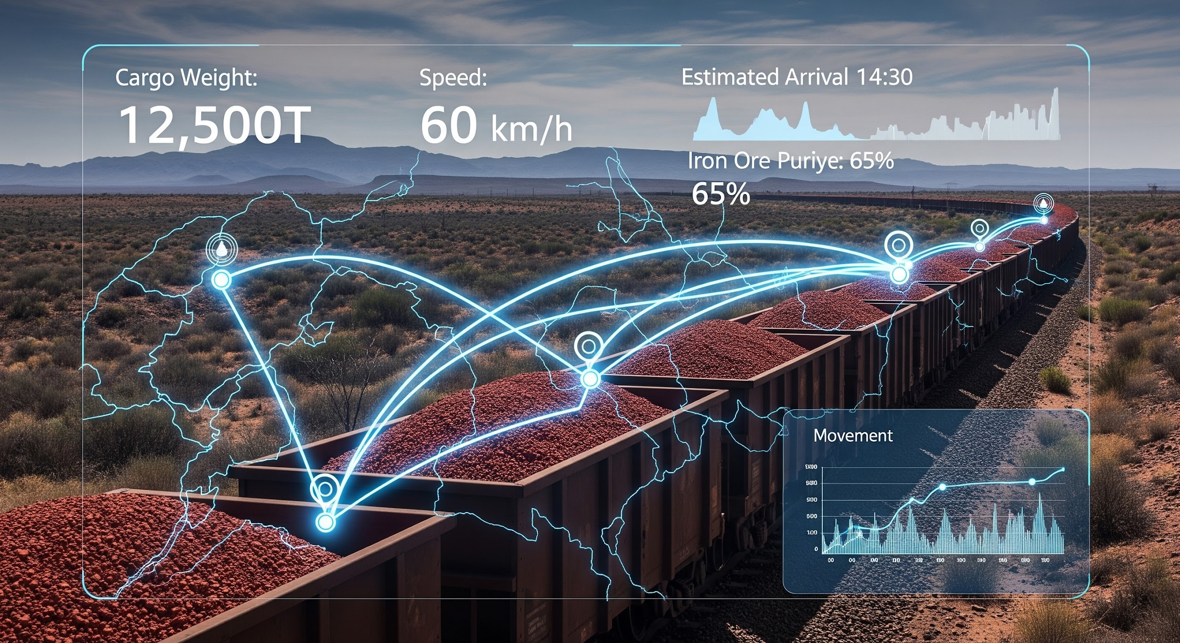

Iron Ore Dispatch System - Requirement Specification Document

1. Introduction

1.1 Purpose of the System
The Iron Ore Rake Dispatch Management System (RDMS) is designed to digitize, manage, and monitor the complete operational lifecycle of iron ore dispatch using railway rakes from mining sidings to customer destinations.
In a typical dispatch yard environment, multiple rakes are placed by railway authorities and loading operations are carried out simultaneously across different sidings and stockpiles. Managing such activities manually or through fragmented systems can lead to operational delays, data inconsistencies, and lack of real-time visibility.
The RDMS application provides a centralized platform that enables operational teams to plan, execute, monitor, and analyze rake loading and dispatch activities in a structured and controlled manner.
The system supports operational teams in performing the following key functions:
- Recording rake placement details as soon as empty wagons arrive at the siding
- Offering the rake for loading against a specific customer requirement or dispatch note
- Monitoring the progress of loading operations including tonnage and stockpile usage
- Recording operational delays such as mechanical issues, railway constraints, or manpower shortages
- Managing load adjustments when wagons are overloaded or unevenly loaded
- Tracking loading completion and recording track clearance time
- Maintaining operational history for each rake until it is considered dispatched
- Generating operational reports and providing real-time dashboard insights for management
By providing structured workflows and real-time operational visibility, the system acts as a Railway Siding Operations Management Tool, helping organizations improve dispatch efficiency, reduce turnaround time, and maintain accurate records for operational decision-making.

1.2 Definition – Rake
A rake refers to a formation of railway wagons coupled together to transport iron ore from a loading location (siding) to a specified customer destination.
Each rake consists of multiple wagons of a specific type and capacity. Loading operations are carried out wagon by wagon, and the total tonnage loaded into the rake is tracked as part of dispatch operations.

Example of a Rake
- Rake Number: OK14
- Wagon Type: NS
- Number of Wagons: 58
- Ore Type: Lumps
- Customer: JSPL Barbil
- Destination: JSLK
In operational terms, a rake is treated as a single dispatch unit. The system maintains detailed information about the rake throughout its lifecycle — from placement to loading completion and eventual dispatch.

2. End-to-End Business Process
The RDMS system supports the complete operational workflow involved in dispatching iron ore through railway transportation.
The typical process flow is described below.
- Rake Placement by Railway
The railway authority places an empty rake at a designated siding within the mining or loading yard. This physical event marks the beginning of the rake lifecycle.
- Recording Rake Placement and Offering for Loading
The operator records rake details in the system, including wagon type, wagon count, siding location, and placement time.
The rake is then offered for loading against a commercial reference such as a dispatch note or customer requirement.
- Initiation of Loading Operations
Once the rake is offered, loading of iron ore begins. The operator assigns loading personnel and selects the stockpile(s) from which ore will be loaded.
- Monitoring and Updating Loading Progress
During loading, the operator updates operational details such as tonnage loaded, wagon health status, and stockpile utilization.
Loading may be performed from multiple stockpiles depending on operational requirements.
- Recording Operational Delays
If any disruption occurs during loading, the operator records delay details including delay category, start time, end time, and reason.
This information is used later for operational analysis and performance improvement.
- Load Adjustment Activities
In cases where wagons are overloaded or unevenly loaded, corrective actions are taken.
The operator records adjustment details such as number of affected wagons and weight removed.
- Completion of Loading
Once all wagons are loaded as per operational requirements, the operator records the loading completion time in the system.
- Track Clearance Recording
After loading completion, the track is cleared for railway movement.
The operator records the track clearance time, indicating that the rake is ready for departure.
- Rake Dispatch
After track clearance and railway movement, the rake is considered dispatched.
The system maintains a complete operational history of the rake for reporting and analysis.
Through this structured workflow, the RDMS system ensures that the entire lifecycle of each rake is tracked, monitored, and documented accurately.

3. User Roles
The RDMS system is designed with a simplified role model consisting of three user roles to ensure clarity in responsibilities and ease of system operation.

3.1 Admin
The Admin role is responsible for overall system configuration, governance, and master data management.

Key Responsibilities
- Creating and managing user accounts
- Assigning appropriate roles and access permissions
- Maintaining master data such as wagon types, sidings, stockpiles, customers, and destinations
- Configuring system parameters and operational settings
- Monitoring system usage and data integrity
- Accessing and reviewing all operational reports
- Monitoring dashboard metrics for overall dispatch performance

Access Rights
Admin users have full access to:
- Master Data Management modules
- Operational screens (view and control level access)
- Reporting and analytics modules
- Dashboard and system monitoring features
Although Admin users have complete system access, they generally do not perform routine operational updates related to rake loading unless required for supervision or exception handling.

3.2 Operator
The Operator role represents the primary operational user responsible for executing day-to-day rake loading and dispatch activities within the yard.

Key Responsibilities
- Creating rake offering entries when a rake is placed
- Updating loading status and operational progress
- Entering FTP or operational reference details
- Recording tonnage loaded from one or more stockpiles
- Monitoring wagon health and marking sick wagons if required
- Recording delay events with proper categorization
- Recording load adjustment details when corrective actions are taken
- Updating loading completion time
- Recording track clearance time once the rake is ready for movement
Operators interact with the system continuously during the loading process and ensure that operational data is captured accurately and in real time.

3.3 Viewer
The Viewer role is intended for stakeholders who require visibility into operations but do not perform any data entry or modification.

Key Responsibilities
- Monitoring rake status and dispatch progress
- Viewing operational reports and summaries
- Accessing dashboard metrics and performance indicators

Access Restrictions
Viewer users cannot:
- Create or modify rake records
- Update loading information
- Record delays or adjustments
- Change master data
This role ensures controlled access to operational information while maintaining data integrity and security.

4. Functional Modules

4.2 Rake Offering Module

4.2.1 Purpose
The Rake Offering module is responsible for recording the physical arrival of a rake at the loading yard and preparing it for loading operations.
This is the first operational transaction in the rake lifecycle and establishes the foundation for all subsequent loading, delay tracking, adjustment, and dispatch activities.
From a business perspective, this module bridges the gap between:
- Railway yard operations (placement of rake)
- Dispatch planning and execution
Accurate recording at this stage is critical because all downstream reporting, operational analytics, and dispatch performance measurement depend on correct rake offering data.

Functional Flow — Create Rake Offering Details
When a rake is physically placed by railway authorities at a siding, the operator must create a rake offering entry in the system.
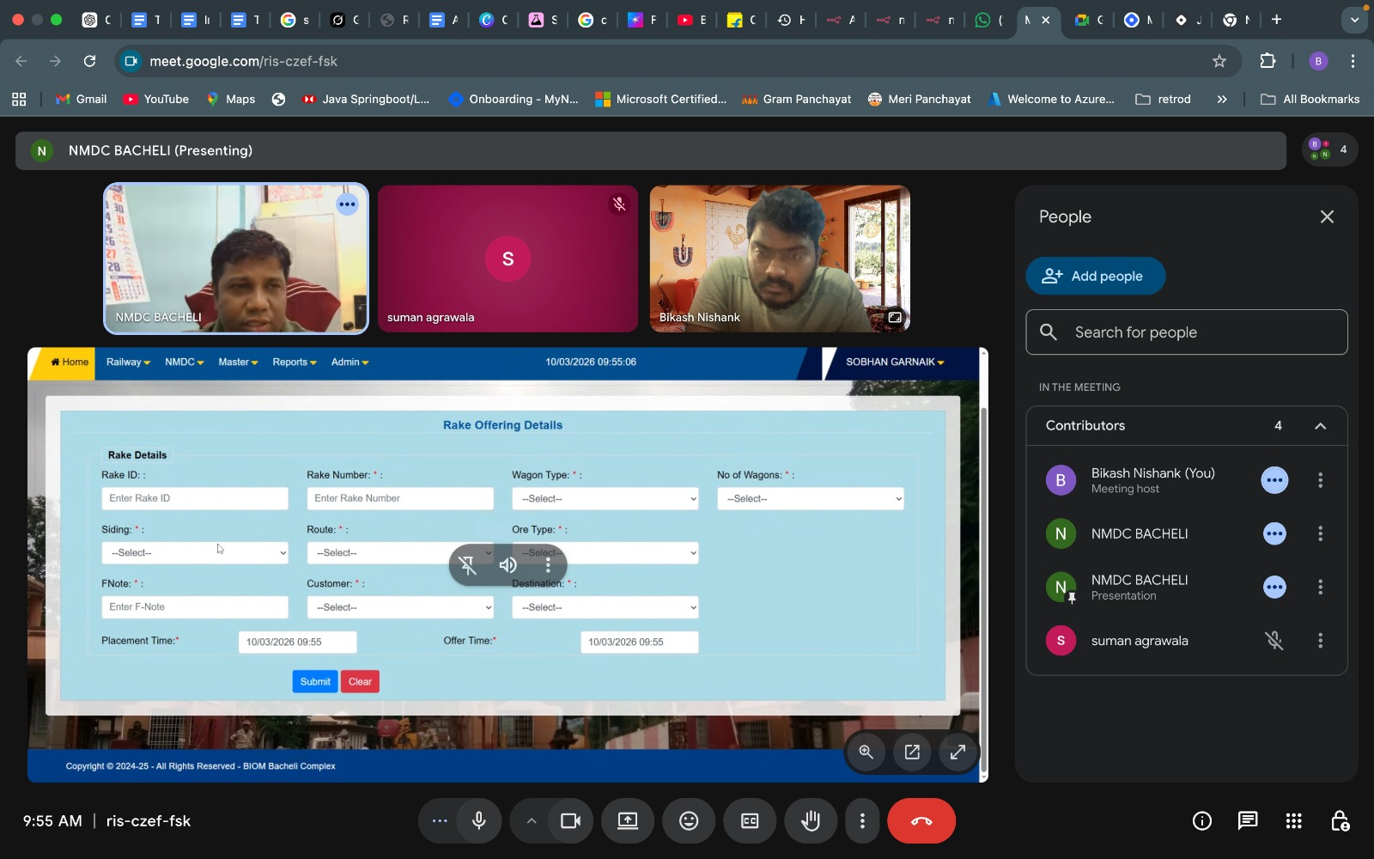

Operator Inputs
The operator records the following details:
- Rake Number
Unique identifier provided by railway authorities for the rake formation.
- Wagon Type
Type of wagons received (e.g., NS, MIX). Determines loading capacity expectations.
- Number of Wagons
Total wagons available for loading.
- Siding Location
Physical track location where rake is placed.
- Route Number
Railway route identifier associated with rake movement.
- Ore Type
Type of ore to be loaded (e.g., LUMP, FINE).
- Customer
Buyer for whom the rake is being prepared.
- Destination
Final delivery point of the rake.
- F-Note / Dispatch Reference
Commercial reference or booking identifier.
- Placement Time
Time when the rake was physically positioned at siding.
- Offer Time
Time when rake was made available for loading.

System Processing
After the operator saves the rake offering:
- The system creates a new rake transaction record.
- Rake becomes visible in the Rake Listing screen.
- Rake is operationally marked as Available for Loading.
- Lifecycle status internally transitions to OFFERED.
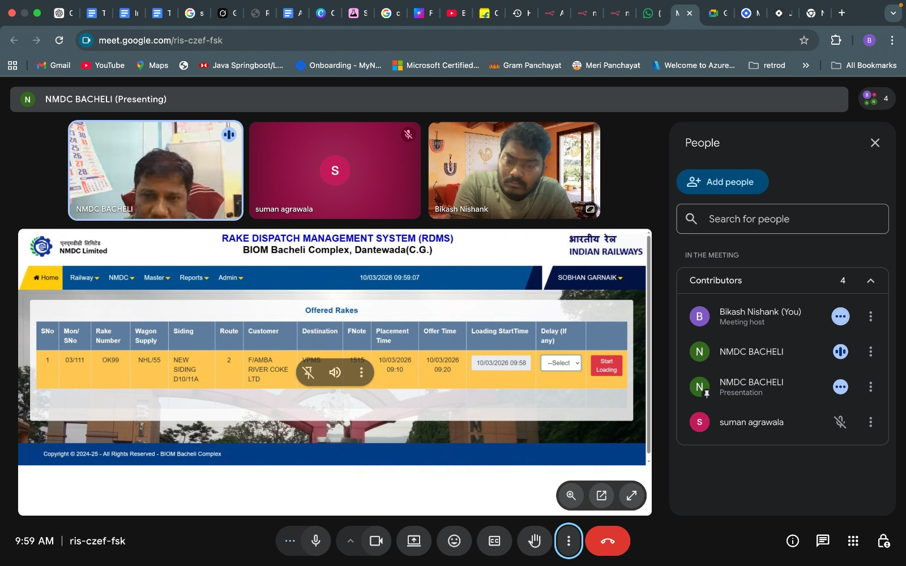

System Validations
- The system must prevent duplicate rake number creation.
- Wagon count must be greater than zero.
- Offer time must be equal to or later than placement time.
- Mandatory fields must be validated before saving.

Additional Behaviour
- Operators may modify rake details until loading activity begins.
- Once the loading update is recorded, rake master details must be locked.
- All changes must be captured in audit logs.

4.3 Rake Listing

Purpose
The Rake Listing provides a consolidated operational view of all rakes that have been offered for loading.
This screen acts as the primary operational workbench for yard operators and enables them to:
- Identify rakes waiting for loading
- Monitor rakes currently under loading
- Track rakes whose loading has been completed

Displayed Information
Each rake row displays:
- Rake Number
- Wagon Type and Wagon Count
- Siding Location
- Route Number
- Customer Name
- Destination
- Dispatch Reference (F-Note)
- Placement Time
- Offer Time

Available Actions
- Edit Rake
Allowed only before loading begins.
- Update Loading Status
Opens loading management screen, where operator has to update the loading details as per the below screenshot.
- 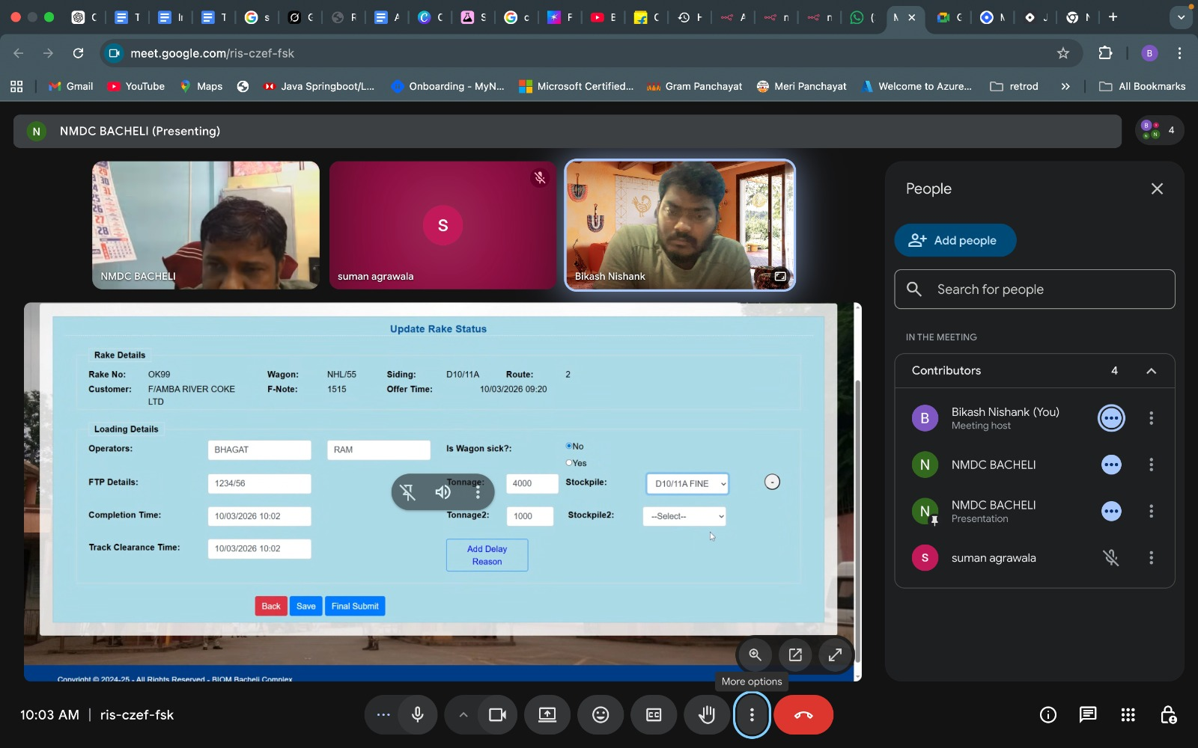

Functional Behaviour
- The system must support sorting by siding, placement time, or rake number.
- The system should allow filtering based on operational status.
- Rake status indicator should help users quickly identify priority tasks.

4.4 Loading Management Module

Purpose
This is the core operational module of the RDMS system.
It captures real-time loading execution details and provides visibility into:
- Loading progress
- Tonnage handled
- Operational disruptions
- Resource utilization
This module directly reflects ground-level yard activities.

4.4.1 Update Rake Status
The operator updates operational details during loading.

Operator Inputs
- Operator Names responsible for loading
- FTP (operational reference number)
- Wagon Sick Indicator (Yes / No)

Tonnage Recording
The system must support loading from multiple stockpiles.
Operator can record:
- Tonnage loaded from Stockpile A
- Tonnage loaded from Stockpile B
System automatically calculates:
Total Loaded Tonnage

Functional Behaviour
- The system must allow progressive tonnage updates during loading.
- The system must store timestamped loading history.
- Wagon sick information must be available for operational reporting.
- The system should warn if tonnage exceeds expected rake capacity.

4.4.2 Completion Update
When loading finishes, operator records:
- Loading Completion Time
- Track Clearance Time

System Processing
System calculates:
- Total Loading Duration
- Net Loading Time excluding delays
After track clearance entry:
- Rake lifecycle transitions to Ready for Dispatch state.

4.5 Delay Management Module

Purpose
This module captures any interruption or constraint faced during loading operations.
Delay tracking is critical for:
- Identifying operational inefficiencies
- Measuring yard performance
- Supporting management decision making

Delay Entry
Operator records:
- Delay Category
- Delay Start Time
- Delay End Time
- Reason Description

Functional Behaviour
- Multiple delay entries must be allowed per rake.
- The system calculates delay duration automatically.
- Delay records must be linked to the rake loading timeline.
- Delay analytics must be available in the reporting module.

4.6 Load Adjustment Module

Purpose
Records corrective loading actions taken due to safety or operational reasons.
Typical scenarios include:
- Overloaded wagons
- Uneven distribution of ore
- Removal of excess material

Data Captured
- Rake Number
- Adjustment Reason
- Number of Overloaded Wagons
- Weight Removed
- Adjustment Clearance Time

Functional Behaviour
- Adjustment must be recorded before dispatch stage.
- The system should maintain adjustment history.
- Adjustment data must be available for compliance reporting.

4.7 Demand Management Module

Purpose
Tracks customer demand requests for ore dispatch.
This module supports dispatch planning by:
- Recording new demand entries
- Monitoring pending demand
- Supporting rake allocation decisions
- 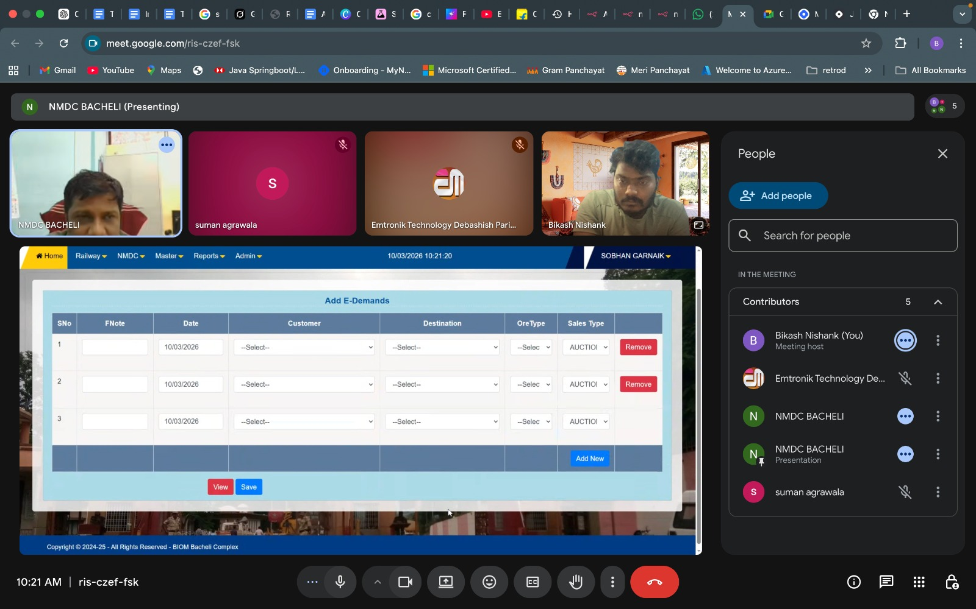

4.8 Permit Management Module

Purpose
Maintains railway authorization details required for rake movement.

Data Managed
- E-Permit Number
- RTP Reference
- Validity Period
This information ensures dispatch compliance.

4.9 Reporting Module
Provides operational and analytical reports.

Key Reports
- Daily dispatch performance
- Monthly dispatch summary
- Customer-wise dispatch
- Delay analysis
- Wagon utilization
Reports help management optimize dispatch planning.

4.10 Dashboard Module
Provides real-time operational overview of yard activities.

Displays
- Total rakes offered today
- Rakes currently loading
- Rakes completed
- Delayed rakes
- Total tonnage handled
Dashboard enables management to monitor operational efficiency and respond proactively.

5. Business Rules (Detailed Functional Behaviour)
Business rules define the operational constraints and system validations that ensure accurate and controlled rake dispatch processing.
These rules must be strictly enforced by the system to maintain data integrity and reflect real yard operations.

5.1 Rake Modification Restriction after Loading Completion
Once loading of a rake is completed and completion time is recorded:
- The rake should be considered operationally finalized.
- System must prevent modification of critical fields such as:
  - Wagon Type
  - Wagon Count
  - Customer
  - Destination
  - Ore Type
  - Siding

Functional Behaviour
- System should lock the rake record after loading completion.
- Only Admin users may be allowed to perform exceptional updates (if required), and such updates must be audit-logged.
- This rule ensures that dispatch records remain reliable for reporting and compliance purposes.

5.2 Delay Entry Restriction after Track Clearance
Delays represent interruptions during loading operations.
After track clearance time is recorded:
- The rake is considered operationally ready for dispatch.
- No further delay should be recorded since loading activity has ended.

Functional Behaviour
- System must disable delay entry once track clearance is updated.
- Attempt to add delay after this stage should result in validation error.
- This ensures accurate calculation of loading duration and delay analysis.

5.3 Load Adjustment Restriction after Dispatch
Load adjustments are corrective actions taken during loading.
Once the rake is marked as dispatched:
- Physical control of the rake is transferred to railway operations.
- No further operational correction is possible.

Functional Behaviour
- The system must block adjustment entry after dispatch status.
- Adjustment history must remain viewable for audit and analysis.

5.4 Tonnage Validation against Rake Capacity
Each wagon type has a predefined loading capacity.
Total tonnage recorded for a rake must not exceed permissible limits.

Functional Behaviour
- The system should validate total entered tonnage.
- If tonnage exceeds expected rake capacity:
  - A warning message should be displayed.
  - The system may either restrict save or require supervisory confirmation.
- This rule helps prevent operational errors and regulatory violations.

5.5 Multiple Stockpile Loading Support
Operationally, loading may occur from more than one stockpile.

Functional Behaviour
- The system must allow entry of multiple tonnage records linked to different stockpiles.
- Total tonnage should be auto-calculated.
- Stockpile-wise loading data should be available in reports.
This rule reflects real yard operational practices.

6. Rake Lifecycle (Operational State Model)
Each rake progresses through defined operational stages from arrival to dispatch.
Tracking lifecycle stages helps:
- Monitor yard performance
- Identify delays
- Provide operational visibility

6.1 Offered
This is the initial stage after rake placement is recorded.

System Behaviour
- Rake becomes visible in operational listing.
- Rake is eligible for loading activities.
- The operator can edit rake details at this stage.

6.2 Loading
This stage begins when the operator starts entering loading details.

System Behaviour
- Operator assignment recorded.
- Tonnage entries initiated.
- Delay tracking enabled.
- Load adjustment allowed.
The system should consider rake as “Loading in Progress”.

6.3 Completed
This stage is reached when loading completion time is recorded.

System Behaviour
- No further tonnage entry allowed.
- Rake details locked for editing.
- Delay entry allowed until track clearance.

6.4 Track Cleared
This indicates loading operation has fully ended and the railway track is free.

System Behaviour
- Delay entry disabled.
- Adjustment entry disabled.
- Rake marked ready for dispatch.

6.5 Dispatched
This is the final lifecycle stage.

System Behaviour
- Rake is considered operationally closed.
- All transaction data becomes read-only.
- Rake included in dispatch reports and analytics.

7. Non-Functional Requirements
Non-functional requirements define system performance, usability, and reliability expectations.

7.1 Role-Based Security
- The system must enforce role-based access control.
- Admin, Operator, and Viewer must have clearly defined permissions.
- Unauthorized access attempts must be prevented.

7.2 Multi-User Support
- The system must allow multiple operators to work simultaneously.
- Concurrent rake updates should not cause data corruption.
- Database transactions must ensure consistency.

7.3 Real-Time Data Visibility
- Changes in loading status should reflect immediately across dashboards and listings.
- The system should support near real-time operational monitoring.

7.4 Audit Logging
- All critical actions must be recorded:
  - Rake creation
  - Loading updates
  - Delay entries
  - Adjustments
  - Master data changes
- Audit logs should include:
  - User ID
  - Timestamp
  - Action performed
This supports traceability and operational accountability.

7.5 High System Availability
- The system should be accessible throughout yard operational hours.
- Downtime must be minimized.
- Backup and recovery mechanisms should be implemented.

7.6 Mobile / Tablet Friendly Interface
- Operators may use handheld devices in the yard environment.
- System UI should support responsive design.
- Key operational screens must be easily usable on tablets.

Tab 4


